Jakob Bernath related to me the story of how Nes Ammim obtained its land, as follows:
His brother, Dr. Hans Bernath, was a doctor in the hospital in Nazareth. He was on friendly terms with the Dutch doctor from Tiberias, Dr. Johan Pilon (LINK). Pilon told Bernath about his idea of founding a Christian settlement in Israel.
But Pilon’s idea was in danger of failing because he couldn´t find any land to buy.
Co-incidentally, Dr. Bernath was called to a Druze village where a member of the sheikh's family had fallen seriously ill. He succeeded in saving the patient´s life. Desiring to show his great gratitude, the sheikh of the village of Abu Snan asked Dr. Bernath to name a wish.
Dr. Bernath asked the sheikh whether he could sell him some land. So the sheikh offered him two tracts of land, one close to Haifa (that is today an industrial zone), and a second one close to Regba. They decided to take the latter area which was situtated close to Lochamei HaGetaot, the kibbutz where the survivors of the Warsaw ghetto had settled. The Druze sheikh Abdullah Khair made Bernath a special offer: one million Swiss francs for 114 dunam of land. Hans Bernath spoke to his brother Jakob in Switzerland and convinced him of the Nes Ammim idea.
Jakob raised the purchase price with credits and donations in Switzerland and Holland. But suddenly there was a problem with the sales procedure. Sheikh Abdullah Khair wanted to sell this land only if he received half of the sale price in Swiss francs deposited in a Swiss bank account! Jakob Bernath succeeded in fulfilling this condition and the Minister of Finance Levi Eshkol (who later became Prime Minister of Israel) approved the sale.
In Europe, an international incorporated company was founded which could appear as an purchaser of land in Israel. The State Associations agreed that Switzerland was the right place to incorporate the company as it was a neutral country. On November 16th 1961, the Nes Ammim AG was founded in Zurich. It had a share capital of 50,000 Swiss francs which at a later date was increased to 100,000 Swiss francs. The four countries Germany, Holland, Switzerland and at the beginning also America took up a quarter of the shares each – as share holders. This AG is approved in Switzerland as a nonprofit organization.
On May 25th, 1962, the Deed of Sale of the land was signed by Sheik Abdullah Salman Saleh Khair, Hans Bernath and Johan Pilon. It was a really ceremonious act.
Owning land in Israel involves a special obligation. The pioneers had now taken a step closer towards achieving their aim and fulfilling their dreams and ideas. It was indeed a considerable step forward.

מתוך: http://www.nesammim.org/nl/sitemap/75.html
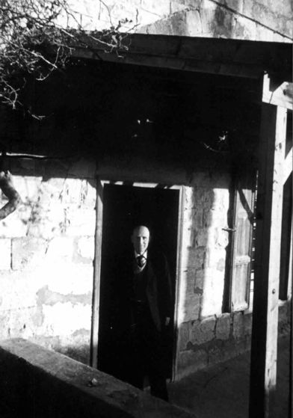
Scheikh Abdullah Kaihr in Abu Snan

